Lab Assignment–1

By: Asavri Kaur(102203940)

**1. Create table Student (Rno, Name, DOB, Gender, Class, College, City, Marks)**

CREATE TABLE student(

Rno number,

Name varchar(10),

DOB date,

Gender varchar(10),

Class number,

College varchar(10),

City varchar(10),

Marks number

);

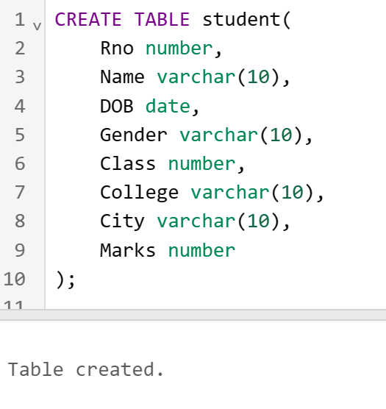

**2. Insert 5 records in student table**

INSERT INTO student(Rno,Name,DOB,Gender,Class,College,City, Marks)

VALUES(1,'tina','12 January 1990','female',1,'thapar','patiala',97);

INSERT INTO student(Rno,Name,DOB,Gender,Class,College,City, Marks)

VALUES(2,'seema','10 May 1990','female',2,'thapar','amritsar',81);

INSERT INTO student(Rno,Name,DOB,Gender,Class,College,City, Marks)

VALUES(9,'meena','7 June 1990','female',3,'thapar','patiala',72);

INSERT INTO student(Rno,Name,DOB,Gender,Class,College,City, Marks)

VALUES(4,'beena','8 July 1990','female',4,'thapar','patiala',12);

INSERT INTO student(Rno,Name,DOB,Gender,Class,College,City, Marks)

VALUES(5,'reema','30 April 1990','female',5,'thapar','patiala',20);

**3. Display the information of all the students**

SELECT * FROM student;

**4. Display the detail structure of student table**

DESC student;

**5. Display Rno, Name and Class information of ‘Patiala’ students.**

SELECT Rno, Name, Class FROM student WHERE City='patiala';

**6. Display information on ascending order of marks**

SELECT * FROM student ORDER BY Marks;

**7. Change the marks of Rno 5 to 89.**

UPDATE student SET Marks=89 WHERE Rno=5;

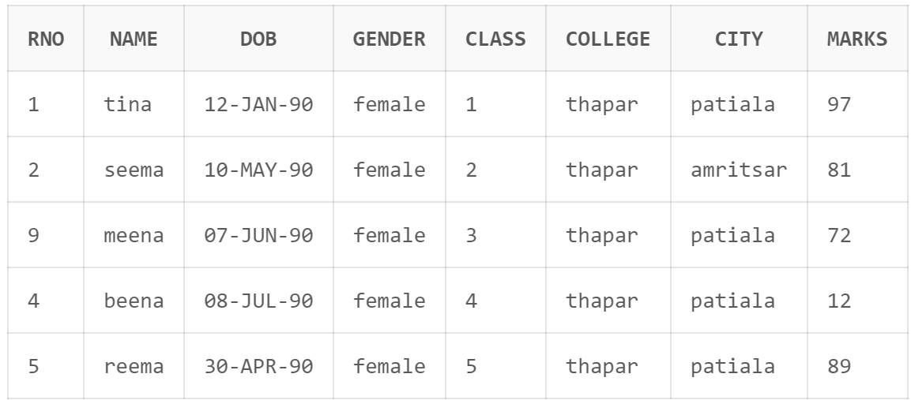

**8. Change the name and city of Rno 9.**

UPDATE student SET Name='leena', City='amritsar' WHERE Rno=9;

**9. Delete the information of ‘Amritsar’ city records**

DELETE FROM student WHERE city = 'amritsar';

**10. Delete the records of student where marks<30.**

DELETE FROM student WHERE marks<30;

